Section #1. Main Page.

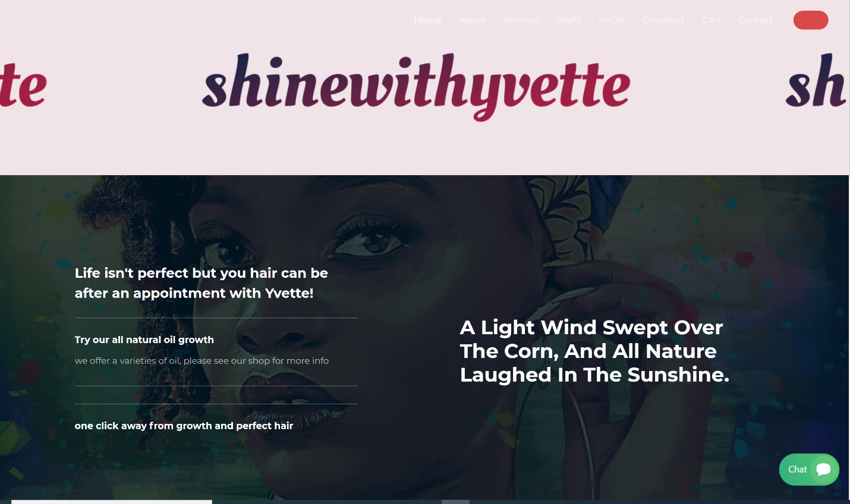

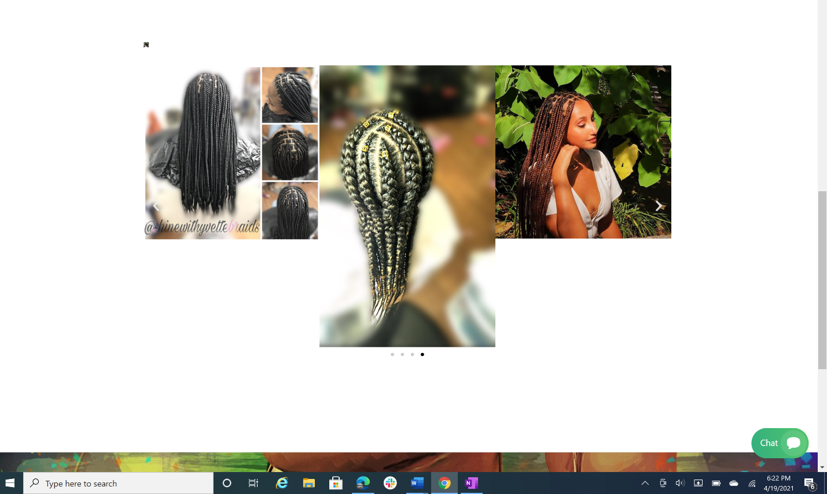

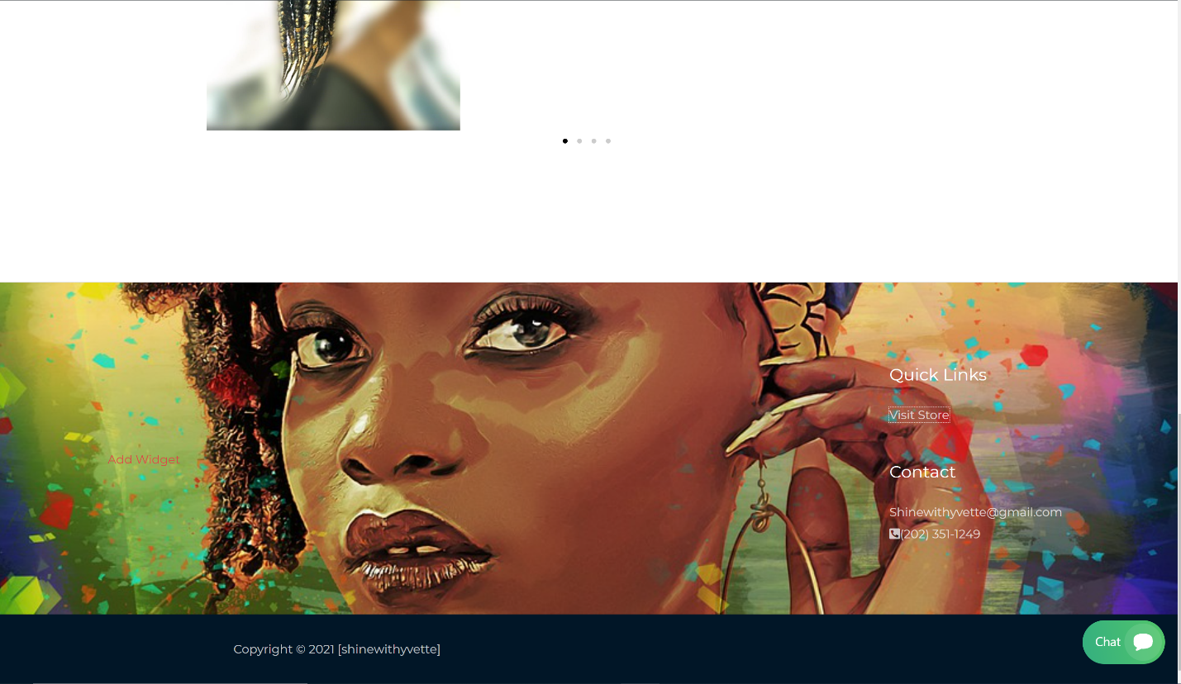

**Focus of the user(s)-First impression**

**Message**: The visitor(s) can identify what the website is about in less than 5 seconds or less

**Next step**: the visitor/users should see where to go next from the main page (click button(s)).

**Visual:** the main page has s central image, gallery, live chat, and a footer with links.

**Invoke the emotion**: does it make a good impression.

Section #2: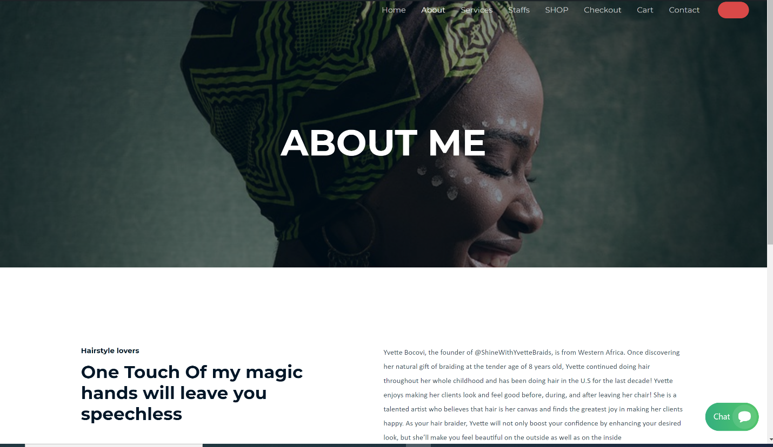

Section #3: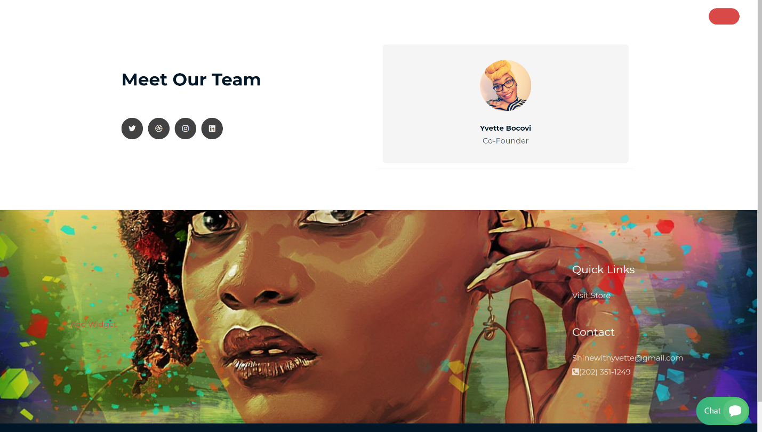

Section #4: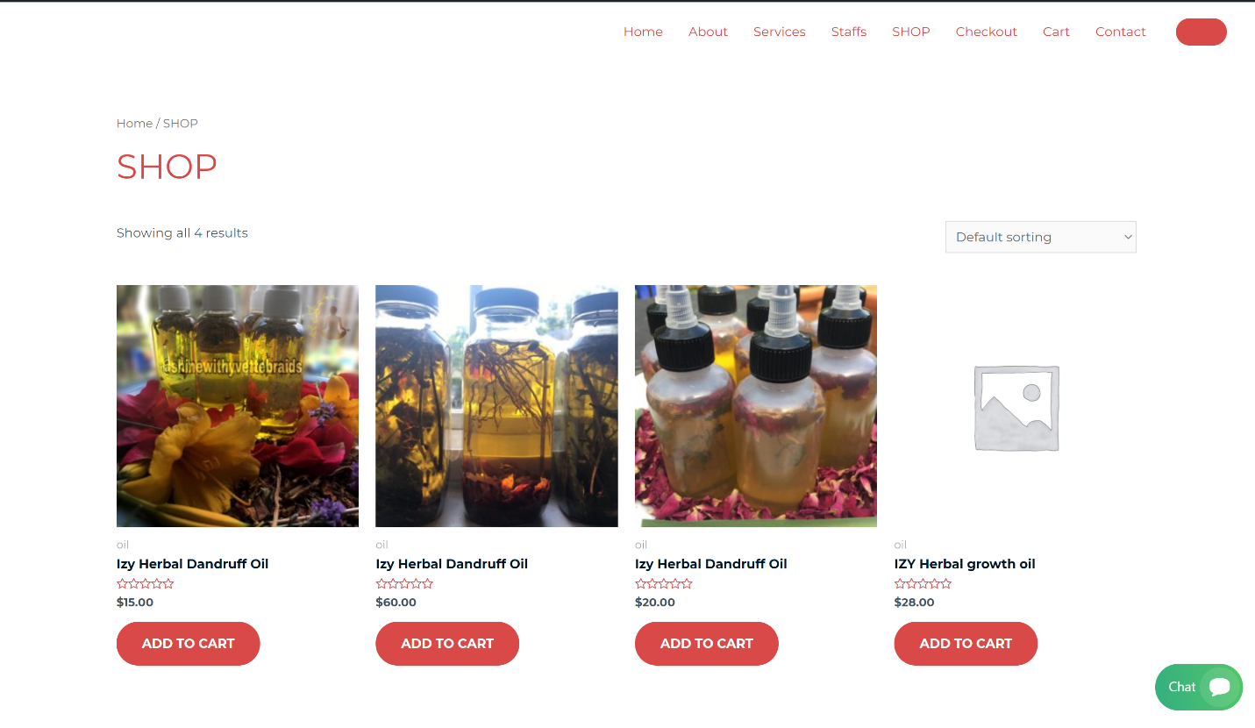

Section#4:

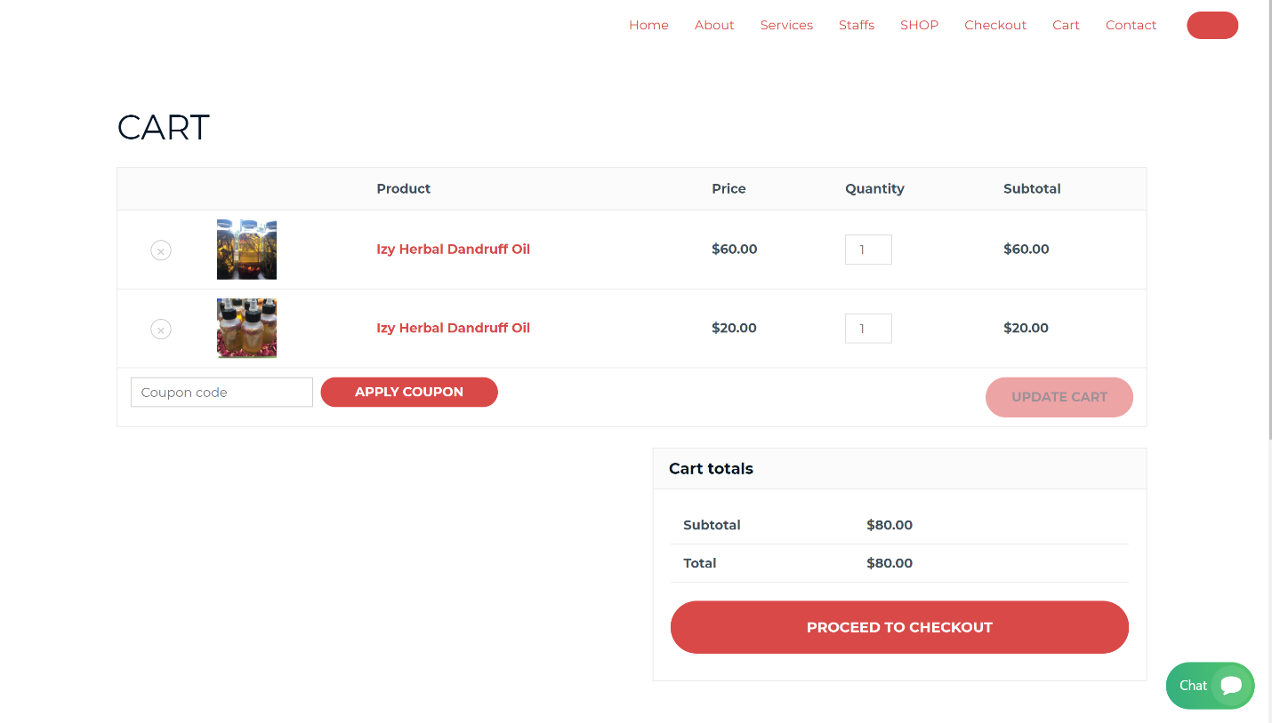

Section#5:

